1. Summarize chapters form 7.1. to 7.4 in the text book.

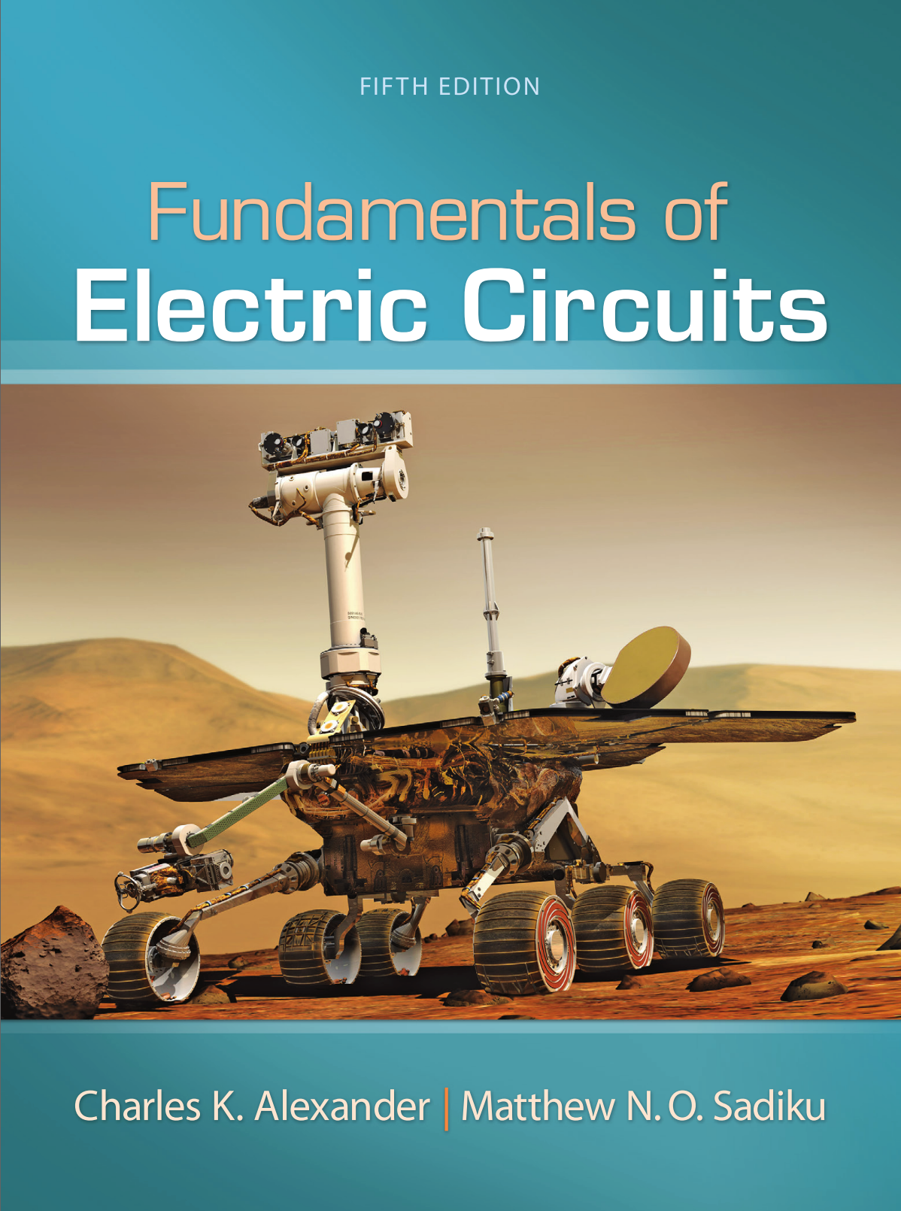

1. Please write the answer to all of the given example in handwriting. And take a picture for the solutions and attach the picture to the assignment file.